

**TVET CURRICULUM DEVELOPMENT, ASSESSMENT AND CERTIFICATION COUNCIL (TVET CDACC)**

**Qualification :** Level 5

**Unit of Competency :** Demonstrate Digital Literacy

**ASSESSOR’S GUIDE WRITTEN ASSESSMENT**

**SECTION A (20 MARKS)**

*In this section, each correct answer is one (1) mark.*

1. Which of the following devices CANNOT be considered a computer? **[1 Mark]**
2. Calculator
3. **Light switch**
4. Digital Fuel pump
5. ATM
6. What is the MAIN focus of ICT? **[1 Mark]**
7. **Information**
8. Communication
9. Technology
10. Informatics
11. In what generation of computers were vacuum tubes used? **[1 Mark]**
12. **1st Generation**
13. 2nd Generation
14. 3rd Generation
15. 4th Generation
16. Computers can be classified according to all the following *except*? **[1 Mark]**
17. Size
18. Purpose
19. Functionality
20. **Shape**
21. The following are the main enemies of a computer system *except*? **[1 Mark]**
22. Dust
23. Heat
24. **Wind**
25. Moisture
26. How can one protect computers from fire? **[1 Mark]**
27. Installing burglar-proof locks
28. Setting up strong passwords
29. Covering the computers with dust covers
30. **Installing fire extinguishers**
31. The activities below are all legal *except?* **[1 Mark]**
32. **Packet sniffing**
33. Deep scanning
34. Disk Defragmentation
35. Virus database updating
36. Which of the following is NOT an application program? **[1 Mark]**
37. Internet browser
38. **File archiver**
39. Spreadsheet
40. CAD software
41. What software below is NOT considered a utility program? **[1 Mark]**
42. Antivirus software
43. Screen saver
44. **Calculator**
45. Backup utility
46. __________ is NOT an example of a Database software. **[1 Mark]**
47. DBase
48. Ms Access
49. Oracle
50. **Quickbooks**
51. How can you define the internet? **[1 Mark]**
52. **Interconnection of networks worldwide**
53. Collection of information found online
54. World wide web
55. Websites and web pages
56. Which of the following is the odd one out? **[1 Mark]**
57. [www.facebook.com](http://www.facebook.com)
58. **maryjane@gmail.com**
59. [www.google.com](http://www.google.com)
60. [www.youtube.com](http://www.youtube.com)
61. The following are parts of an email message *except?* **[1 Mark]**
62. Sender address
63. Recipient address
64. **URL**
65. Subject
66. The following document types are usually designed using DTP *except*? **[1 Mark]**
67. Calendars, brochures, fliers
68. Certificates, newsletters, posters
69. Newspapers, magazines, banners
70. **Letters, memos, minutes**
71. An element that extends to the edge of a page in DTP is known as; **[1 Mark]**
72. **Bleed**
73. Leading
74. Kerning
75. Tracking
76. Thee spacing between different lines of text in DTP in known as; **[1 Mark]**
77. Bleed
78. **Leading**
79. Kerning
80. Tracking
81. Which paper size below is most suitable when designing a newspaper? **[1 Mark]**
82. **A1**
83. A2
84. A3
85. A4
86. What is a slide? **[1 Mark]**
87. **A single page of a presentation**
88. A collection of pages making up a presentation
89. An element within a page of a presentation
90. A transition effect of a presentation
91. What can you NOT insert within a slide? **[1 Mark]**
92. An image
93. An audio clip
94. A video clip
95. **Another slide**
96. A slide show presentation is suitable for the below activities *except*? **[1 Mark]**
97. Presenting a proposal to investors
98. Demonstrating a procedure in a class
99. Conducting a lecture
100. **Performing a practical**

**SECTION B: (40 MARKS)**

***Note to assessor: These are suggested answers to act as guidelines***

1. Differentiate between the terms *software* and *program*. (2 marks)

**Software are any parts of a computer system which are not tangible and may include files, data, information, programs; while a program is a set of instructions which guide a computer on what to do. 2 Marks**

1. Explain TWO ways in which computers are used in industry. (4 marks)
2. **They are used to automate the manufacturing process by performing tasks that are usually done by human beings.**
3. **They perform tasks that can prove to be risky for human beings, like complex engineering processes.**
4. **They are used for security by use of CCTV cameras and automatic alarms**
5. **They can be used to simulate whole production processes, as is the case with 3D printing.**

**Any 2 at 2 Marks each**

1. Outline THREE challenges in the use of computers. (3 marks)
2. **Use of computers has caused many people to lose jobs after their work was taken over by the computers**
3. **Employees have been deployed to less prestigious jobs after their jobs are now being done by computers**
4. **Use of computers has led to an increase in electronic waste**
5. **Prolonged use of computers had led to health problems like backache and neck pains**
6. **Over-reliance on computers has led to poor development of social skills and interpersonal relations Any 3 at 1 Mark each**
7. Give any TWO types of viruses. (4 marks)
8. ***Boot sector virus* – attacks the computer’s boot files**
9. ***Web scripting virus* – blends into the background of popular websites disguised as a normal link and tempting you to click**
10. ***Resident virus* – stores itself in the computer memory and activates itself whenever the computer performs an action**
11. ***Browser hijacker* – takes over your internet searches and redirects you to pages you did not want to visit**
12. ***Trojan horse* - disguised as a normal program or file and runs in the background to gain access to your private information**

**Any 2 at 2 Marks each**

1. Describe TWO laws which govern the use of ICT in Kenya. (4 marks)
2. **Kenya Communications Act 2009 – provides the main framework for regulating the communications sector in Kenya**
3. **Access to Information Act – creates a framework to facilitate access to information held by private bodies**
4. **Data Protection Act – seeks to protect Kenyan individuals’ rights and interests and applies to data controllers and data processors. Any 2 at 2 Marks each**
5. State any THREE types of operating systems. (3 marks)
6. **Batch operating System**
7. **Multitasking operating system**
8. **Time-sharing operating system**
9. **Real time operating system**
10. **Distributed operating system**
11. **Network Operating system**
12. **Mobile operating system**
13. **Embedded operating system Any 3 at 1 Mark each**
14. Outline any TWO properties of operating systems. (2 marks)
15. **Operating systems work using batch processing**
16. **They use multitasking and multiprogramming**
17. **They provide features of interactivity between the system and users**
18. **They facilitate spooling of data and input/ output devices**

**Any 2 at 1 Mark each**

1. Explain any TWO types of cell referencing as used in spreadsheets. (4 marks)
2. ***Relative cell referencing* – refernces change when a formula is copied to another cell**
3. ***Absolute cell referencing* – references remain constant no matter where they are copied**
4. ***Mixed cell referencing* – contains both relative and absolute cell references**

**Any 2 at 2 Marks each**

1. What are the TWO main types of network transmission media? (4 marks)
2. ***Guided/ bounded/ wired* – signals are confined to a fixed pathway using physical links**
3. ***Unguided/ unbounded/ wireless* – no physical media is required for transmission of signals**

**2 Marks each × 2**

1. Give TWO challenges associated with using the internet. (4 marks)
2. ***Waste of time* – one might spend a lot of time online while doing nothing constructive**
3. ***Cyber crime* – the internet has facilitated some forms of crime which thrive online, like internet fraud, hacking, identity theft, etc**
4. ***Pornography* – internet provides easy exposure to pornography and other harmful material**
5. ***Viruses and malware* – the internet exposes our computers to attacks f by viruses and malware.**
6. ***Cyber bullying* – social media is being used to cause hurt to some users through cyber bullying**

**Any 2 at 2 Marks**

1. List any THREE examples of DTP software. (3 marks)
2. **Microsoft Publisher**
3. **Adobe Pagemaker**
4. **CorelDraw**
5. **Pagestream**
6. **Adobe InDesign Any 3 at 1 Mark each**
7. Outline THREE advantages of electronic presentations over traditional flipcharts. (3 marks)
8. **Easy to prepare and edit**
9. **Cheaper to prepare**
10. **Has more variety of presentation features like videos and audio**
11. **Very suitable for summarizing facts**
12. **allows the presenter to face the audience while making the presentation**

**Any 3 at 1 Mark each**

**SECTION C: (40 MARKS)**

***Note to assessor: These are suggested answers to act as guidelines***

*Only TWO questions attempted.*

1. List the items needed in order to set up a desktop PC. (6 marks)
2. **Monitor**
3. **System unit**
4. **Keyboard**
5. **Mouse**
6. **Power cables**
7. **Video/ VGA cable**

**1 Mark each × 6**

1. Outline the procedure for assembling a desktop PC. (8 marks)
2. **Connect the keyboard and mouse to the system unit [2 Marks]**
3. **Connect the monitor to the system unit using the video cable [1 Mark]**
4. **Connect the monitor to mains electricity using a power cable, but do not turn it on [1 Mark]**
5. **Connect the system unit to mains electricity using a power cable, but do not turn it on [1 Mark]**
6. **Confirm that all cables are connected firmly, then power up the system unit and monitor[1 Mark]**

**2 Marks for correct flow of steps**

1. Explain THREE advantages of a desktop PC over a laptop. (6 marks)
2. **Desktop PC is easy to repair and maintain as the components can be easily be detached from the system and replaced.**
3. **It is easy to upgrade since it has provisions for addition of various hardware modules**
4. **Servers for networks are usually designed as desktop PCs, not as laptops**
5. **Desktop PCs do not easily heat up so have lower chances of components frying.**

**Any 3 at 2 Marks each**

1. What is a network topology? (2 marks)

**This refers to the arrangement of components in a computer network in relation to each other**.

**2 Marks**

1. With the aid of diagrams, describe any THREE network topologies. (15 marks)

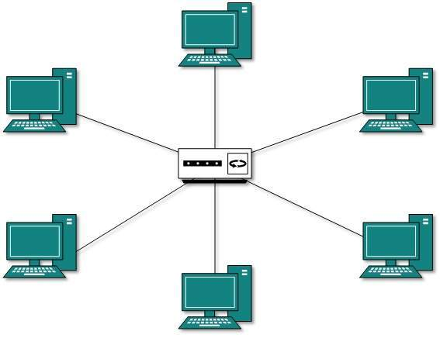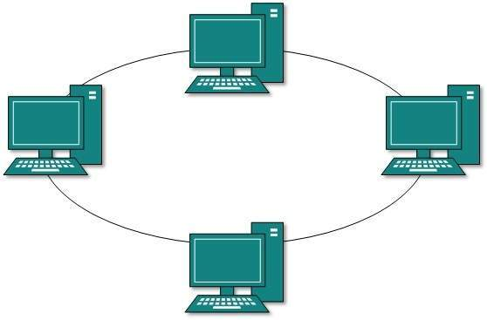

**Ring Topology**

**Star Topology**

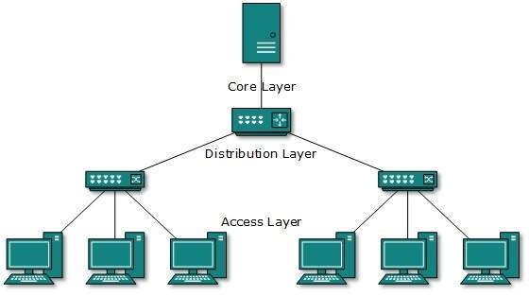

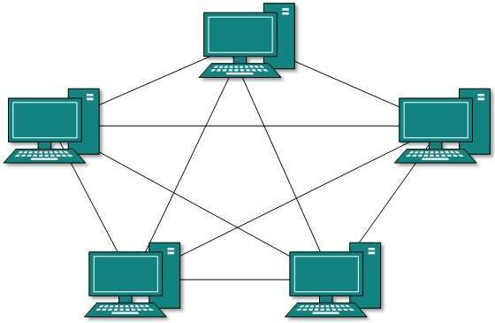

**Tree Topology**

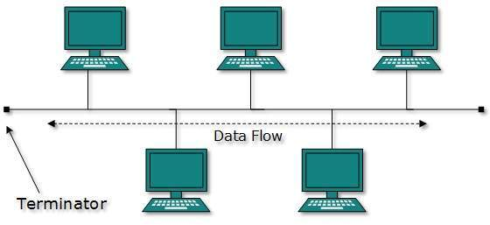

**Mesh Topology**

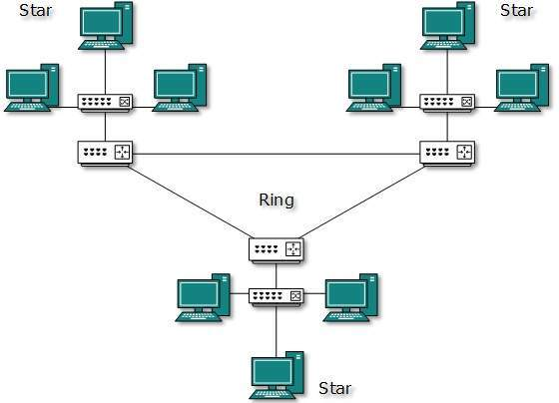

**Hybrid Topology**

**Bus Topology**

**Any 3 at 5 Marks each**

1. Outline ONE area where EACH topology given above can be used. (3 marks)
2. **Ring topology – small business with one office and a few devices**
3. **Start topology – small business with several offices and one server**
4. **Bus topology – computer lab with several computers and a switch**
5. **Tree topology – large organization with several levels of access**
6. **Hybrid topology – large organization with several remote offices**

**Any 3 at 1 Mark each**

1. Describe any FIVE categories of computer applications, giving an area of application for each. (10 marks)
2. **Word processors – used to create electronic word documents**
3. **Spreadsheets - used to perform calculations on large volumes of numeric data**
4. **Databases – used for stroing and manipulating records in an organized manner**
5. **Presentation software – used for making electronic presentations**
6. **Financial accounting – used for working with data in form of currency**
7. **Statistical analysis software – used to perform analysis of large volumes of numeric data**
8. **Browsers – used to open pages on the internet**
9. **Email – used for managing electronic mail messages Any 5 at 2 Marks each**
10. Describe how the operating system handles each of the following tasks;
11. Job scheduling. (2 marks)

**Keeping track of time and resources used by various jobs and users. [2 Marks]**

1. Memory management. (2 marks)

**Keeps tracks of primary memory, i.e., what part of it are in use by whom, what part are not in use [2 Marks]**

1. Input/ Output management. (2 marks)

**Keeps tracks of all devices. Program responsible for this task is known as the I/O controller. It decides which process gets the device when and for how much time. [2 Marks]**

1. Error detection (2 marks)

**Production of dumps, error messages, and other debugging and error detecting aids. [2 Marks]**

1. Processor management. (2 marks)

**Keeps tracks of processor and status of process. The program responsible for this task is known as traffic controller. Allocates the processor (CPU) to a process [2 Marks]**